|  |  |
| --- | --- |
| **Name :-** | Aryan Dilipbhai Langhanoja |
| **Enroll No: -** | 92200133030 |

## Basics of OR gate and its application in industrial control

* **Aim** :-

The aim of this experiment is to apply the basic OR gate logic in industrial control process. The user will be able to drag and drop the OR gate on the blank canvas and make input-output connections and verify the truth table.

* 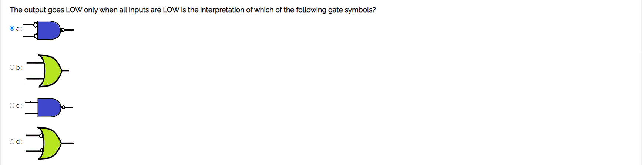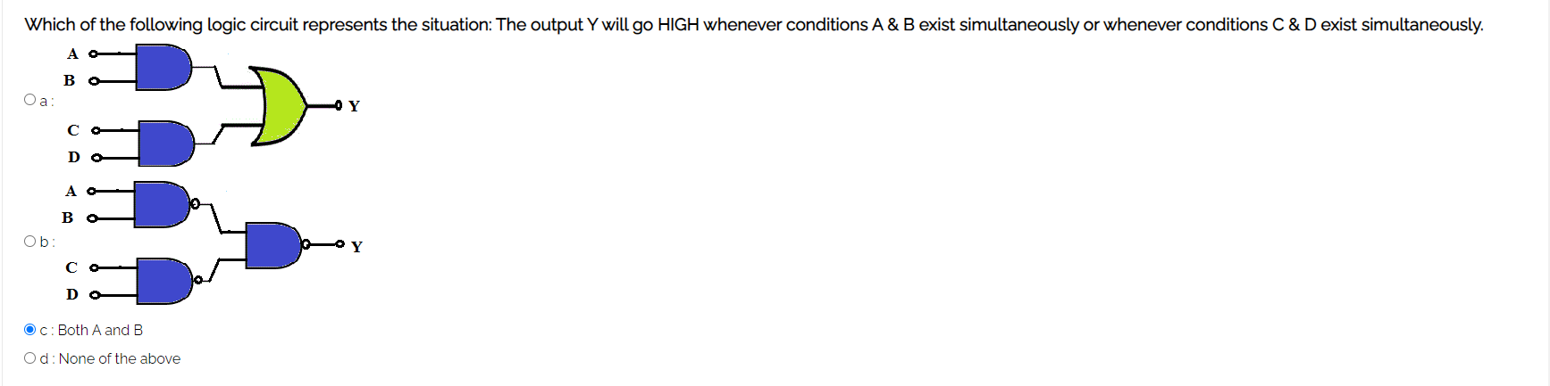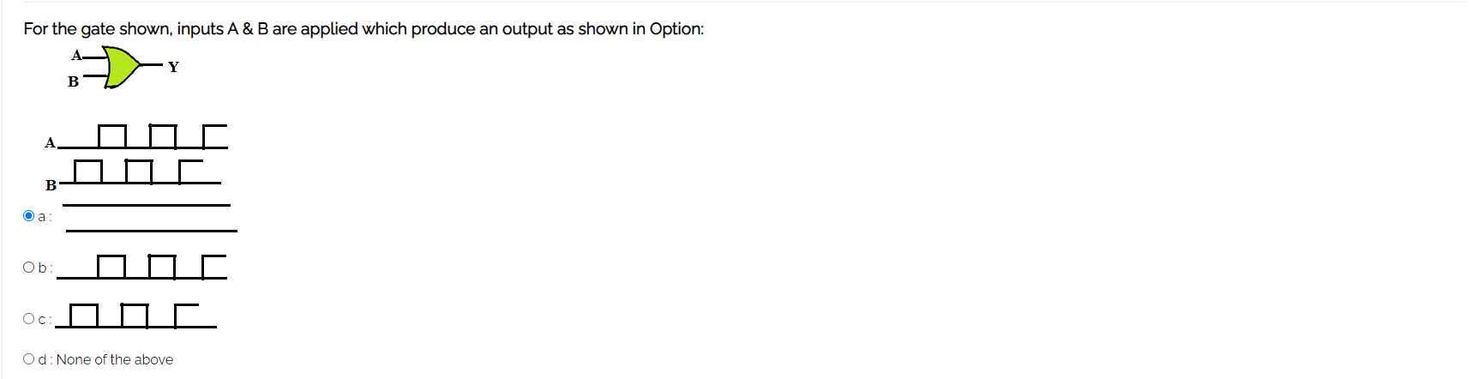**Pre-test :-**

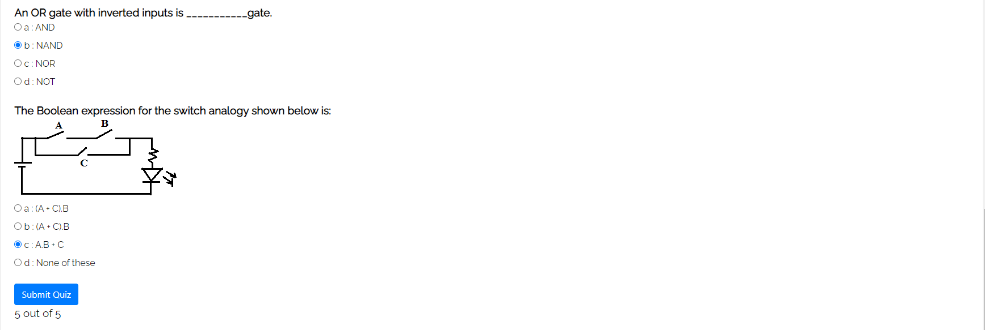

* **Simulation :-**

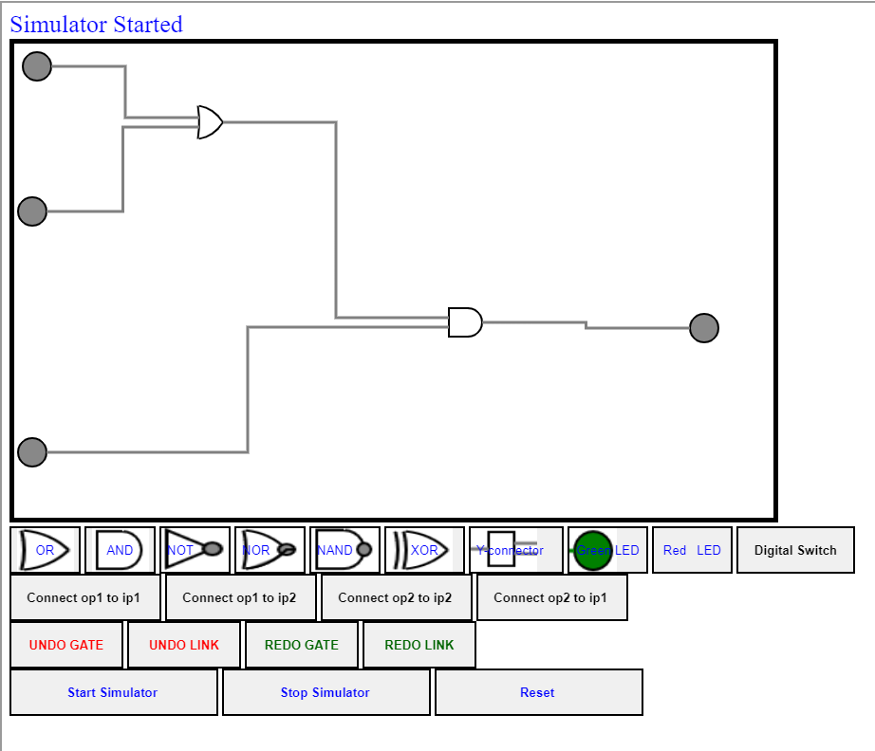

* 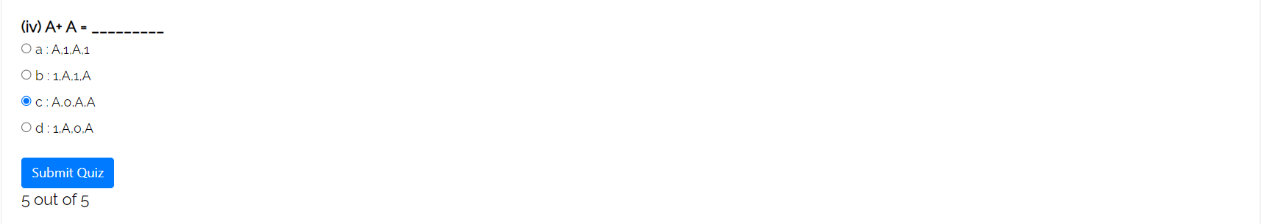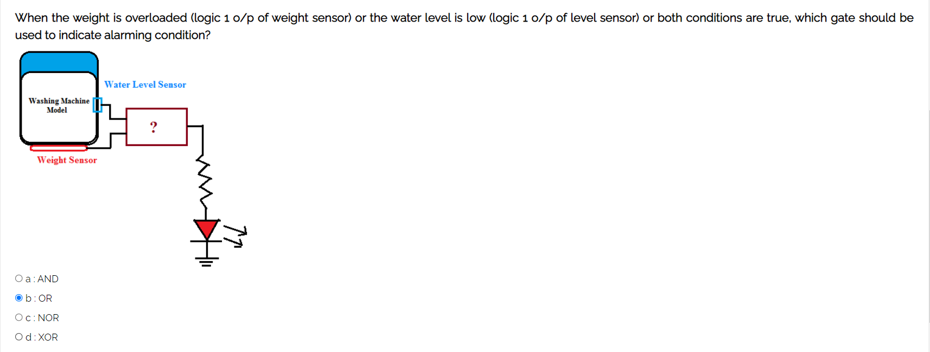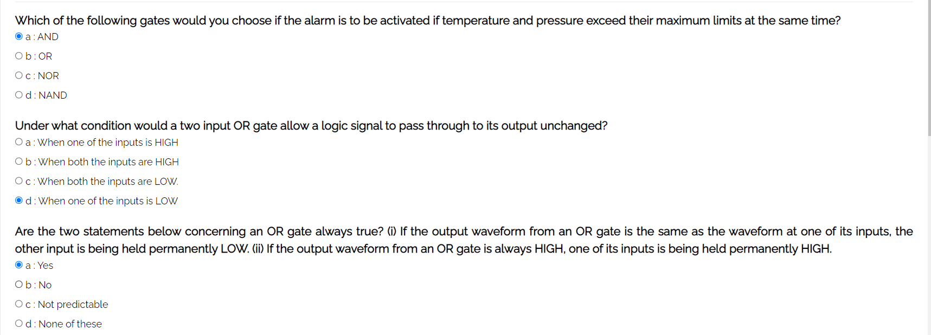**Post-test :-**